Name: Samantha Grace M. Dalma
Yr. & Section: IV-7 BSEVE
Reporter #: 18
Topic: Experiential Learning Cycle

Objectives:  At the end of this lesson, the students would be able to:  a. state the parts of experiential learning cycle;  b. recognize the value of experiential learning cycle ; and  c. follow the cycle in future works.  Materials:  LCD Projector  Cartolina (for the group activity)  PowerPoint Presentation  White Board Marker or Chalk  References:  Experiential Learning: Theoretical Underpinnings: Bart P. Beaudin Associate Professor; Colorado State University & Don Quick; Research Associate Colorado State, University, Pfeiffer, J. William and John E. Jones. Reference Guide to Handbooks and Annuals (1983 Edition). San Diego: University Associates, 1983. 4 (Adapted by Brenda K. Stegall), Experiential Learning Model by Paul Westlake, Jones, J.E. & Pfeiffer, J.W., eds. The 1973 Annual Handbook for Group Facilitator. San Diego: University Associates), 1973. (Adapted by Pamela M. Wilson), Kolb - Learning Styles by Saul McLeod published 2010, updated 2013, | Activity: Make your own Cycle  The whole class will watch the comic presentation presented by the teacher. They will watch the steps on how to make origami. The teacher will bring the students in the cycle of experiential learning through teaching on how to make an origami.  Processing Questions:  C 1. What are the steps did you observe?  C 2. How did you come up with your product?  A 3. Do you find it difficult to make an origami? Why or why not?  C 4. What do you think is the connection of making an origami to experiential learning cycle?  B 5. Would you prefer to use the cycle in the future?
Abstraction:  Kolb – Learning Styles  David Kolb published his learning styles model in 1984 from which he developed his learning style inventory.  Kolb's experiential learning theory works on two levels: a four stage cycle of learning and four separate learning styles. Much of Kolb’s theory is concerned with the learner’s internal cognitive processes.  Kolb states that learning involves the acquisition of abstract concepts that can be applied flexibly in a range of situations. In Kolb’s theory, the impetus for the development of new concepts is provided by new experiences.  “Learning is the process whereby knowledge is created through the transformation of experience” (Kolb, 1984, p. 38).  The Experiential Learning Cycle  Kolb's experiential learning style theory is typically represented by a four stage learning cycle in which the learner touches all the bases':  - Concrete Experience - (a new experience of situation is encountered, or a reinterpretation of existing experience).  - Reflective Observation (of the new experience. Of particular importance are any inconsistencies between experience and understanding). | - Abstract Conceptualization (Reflection gives rise to a new idea, or a modification of an existing abstract concept).  - Active Experimentation (the learner applies them to the world around them to see what results).  Effective learning is seen when a person progresses through a cycle of four stages: of (1) having a concrete experience followed by (2) observation of and reflection on that experience which leads to (3) the formation of abstract concepts (analysis) and generalizations (conclusions) which are then (4) used to test hypothesis in future situations, resulting in new experiences.  Kolb (1974) views learning as an integrated process with each stage being mutually supportive of and feeding into the next. It is possible to enter the cycle at any stage and follow it through its logical sequence.  However, effective learning only occurs when a learner is able to execute all four stages of the model. Therefore, no one stage of the cycle is an effective as a learning procedure on its own.
Learning Styles  Kolb's learning theory (1974) sets out four distinct learning styles, which are based on a four-stage learning cycle (see above).  Kolb explains that different people naturally prefer a certain single different learning style. Various factors influence a person's preferred style. For example, social environment, educational experiences, or the basic cognitive structure of the individual.  Whatever influences the choice of style, the learning style preference itself is actually the product of two pairs of variables, or two separate 'choices' that we make, which Kolb presented as lines of axis, each with 'conflicting' modes at either end:  A typical presentation of Kolb's two continuums is that the east-west axis is called the Processing Continuum (how we approach a task), and the north-south axis is called the Perception Continuum (our emotional response, or how we think or feel about it). | Importance of knowing experiential learning cycle.  - Experiential learning teaches students the competencies they need for the real world success.  - Authentic experiences prepare students to discover how discipline creates evidence to contribute to its body of knowledge.  - Experiential learning motivates students, especially when they engages in a learning experiences that they see the relevance in life.  - Students have the tendencies to increase motivation to learn when they are provided opportunities for practices and feedback.  - Experiential learning creates self-directed learners, students are experience some unfamiliar situation and tasks in real world context. To complete this tasks, student need to figure out what they know, what they do not know, and how to learned it.
Graphic Organizer

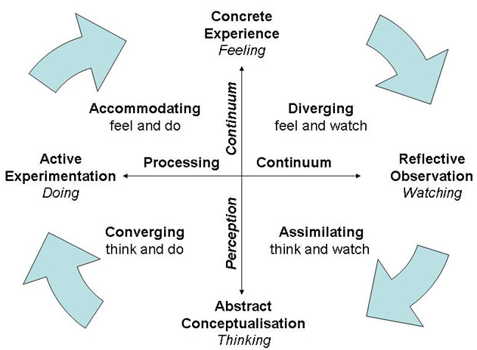

EXPERIENCING
(Activity, “doing”)
(theory)

APPLYING PROCESSING
(Planning ways to use what has been learned (Sharing and discussing reactions and observations)

(theory)

GENERALIZING
(Determining how the experience
relates to the “real world”)

