Name: Gamboa, Avery V.
Yr. and Sec.: IV-7 BSE Values Education
Reporter No.: 16
Topic: Problem Solving
OBJECTIVES:  At the end of the discussion, the students must be able to:  C: define the word problem solving and identify problem solving stages.  A: examine their own ways of solving problems in a certain situations.  B: apply the problem solving stages in different problems that they are encountering.  MATERIALS:  - clean paper  - box  REFERENCES:  - http://www.skillsyouneed.com/ips/  problem-solving.html  - http://www.education.com/reference/  article/problem-solving1/  - https://www.mindtools.com/pages/article/  newTMC_00.htm  - http://www.kent.ac.uk/careers/sk/problem-solving-skills.htm | ACTIVITY:  Direction: The class will be divided into three groups. Each group will be given a paper and marker with strings tied on it. The group will draw a house without touching the marker but they will only control it by pulling the strings.  PROCESSING QUESTIONS:  - How did you find doing the activity? Why?  - Is there any problem that your group experienced while doing the activity? Explain.  - What did you realized while doing the activity?  - In working with the group, how do you usually solve problems?
ABSTRACTION:  Problem  A matter or situation regarded as unwelcome or harmful and needing to be dealt with and overcome.  Problem Solving  Problem solving is cognitive processing directed at transforming a problem from the given state to the goal state when the problem solver is not immediately aware of a solution method.  Stages of Problem Solving  - Problem Identification  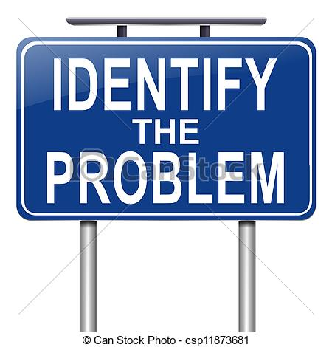  This stage involves: detecting and recognizing that there is a problem; identifying the nature of the problem; defining the problem.  The first phase of problem solving may sound obvious but often requires more thought and analysis. Identifying a problem can be a difficult task in itself, is there a problem at all? What is the nature of the problem, are there in fact numerous problems? How can the problem be best defined? - by spending some time defining the problem you will not only understand it more clearly yourself but be able to communicate its nature to others.  organizations different people will have different expertise in different areas and it is useful, therefore, to hear the views of each concerned party.  - Making a Decision  This stage involves careful analysis of the different possible courses of action and then selecting the best solution for implementation.  This is perhaps the most complex part of the problem solving process. Following on from the previous step it is now time to look at each potential solution and carefully analyze it. It is important at this stage to also consider what might happen if nothing was done to solve the problem - sometimes trying to solve a problem that leads to many more problems requires some very creative thinking and innovative ideas.  5. Implementation  This stage involves accepting and carrying out the chosen course of action.  Implementation means acting on the chosen solution. During implementation more problems may arise especially if identification or structuring of the original | - Structuring the Problem  This stage involves: a period of observation, careful inspection, fact-finding and developing a clear picture of the problem.  Following on from problem identification,  structuring the problem is all about gaining more information about the problem and increasing understanding. This phase is all about fact finding and analysis, building a more comprehensive picture of both the goal(s) and the barrier(s). This stage may not be necessary for very simple problems but is essential for problems of a more complex nature.  - Looking for Possible Solutions  During this stage you will generate a range of possible courses of action, but with little attempt to evaluate them at this stage.  From the information gathered in the first two phases of the problem solving framework it is now time to start thinking about possible solutions to the identified problem. In a group situation this stage is often carried out as a brain-storming session, letting each person in the group express their views on possible solutions (or part solutions). In  problem was not carried out fully.  6. Monitoring/Seeking Feedback  The last stage is about reviewing the outcomes of problem solving over a period of time, including seeking feedback as to the success of the outcomes of the chosen solution.  The final stage of problem solving is concerned with checking that the process was successful. This can be achieved by monitoring and gaining feedback from people affected by any changes that occurred. It is good practice to keep a record of outcomes and any additional problems that occurred.
PROBLEM SOLVING

Problem Solving
Problem solving is cognitive processing directed at transforming a problem from the given state to the goal state when the problem solver is not immediately aware of a solution method.

Problem
- A matter or situation regarded as unwelcome or harmful and needing to be dealt with and overcome.

Monitoring/
Seeking Feedback
Implementation
Making a Decision
Looking for Possible Solutions

Stages of Problem Solving

Problem Identification

Structuring the Problem

